# **Framing**

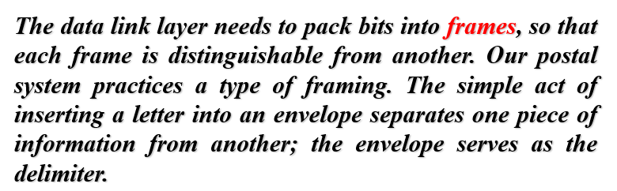

# **Responsibilities of the data-link layer**

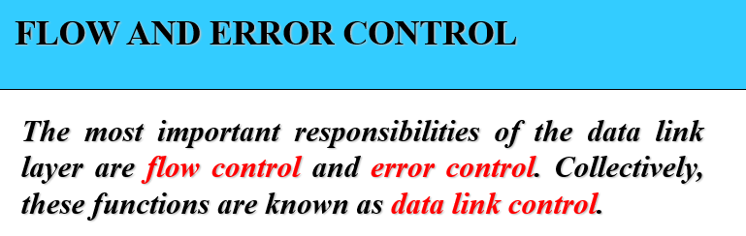

# **Flow Control**

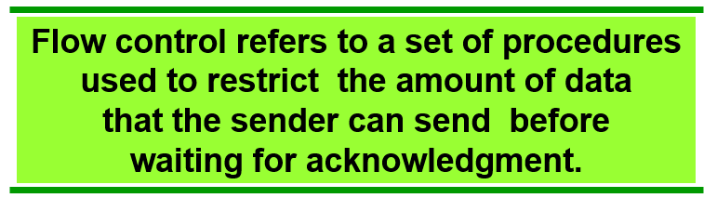

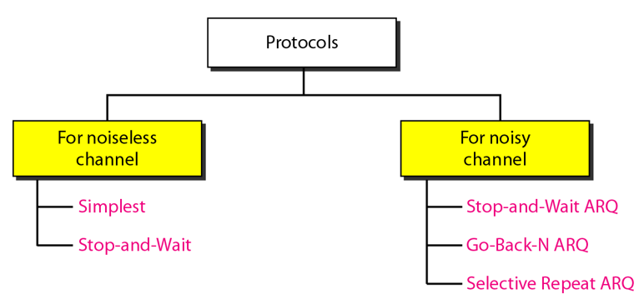

# **Noise-less channel**

## **Simplest**

No flow and error control and only unidirectional (sender to receiver).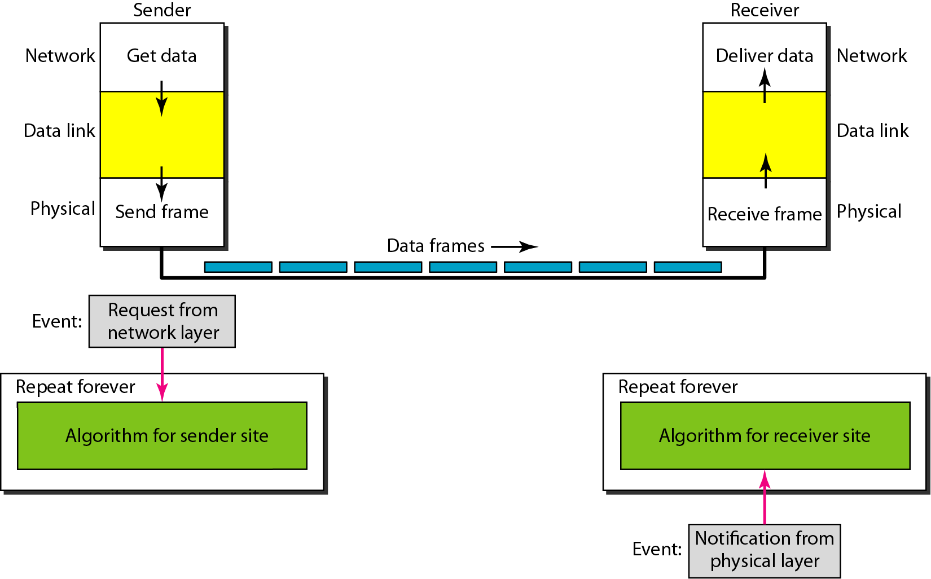

The sender sends the sequence of frames with-out even thinking about the receiver.

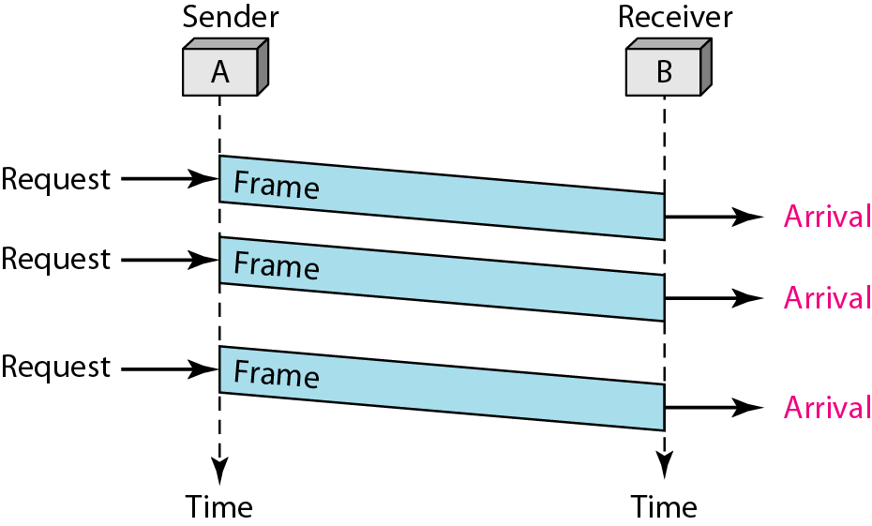

## **Stop and Wait**

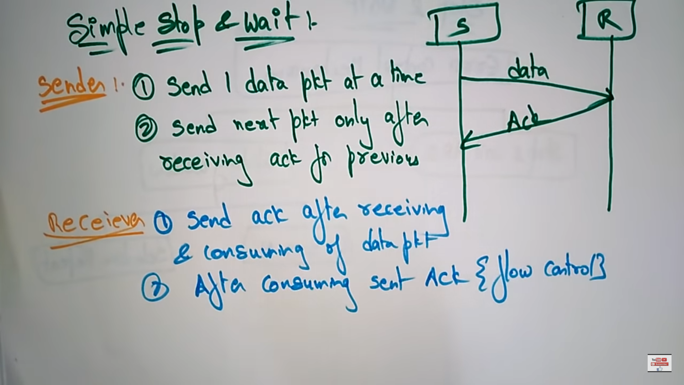

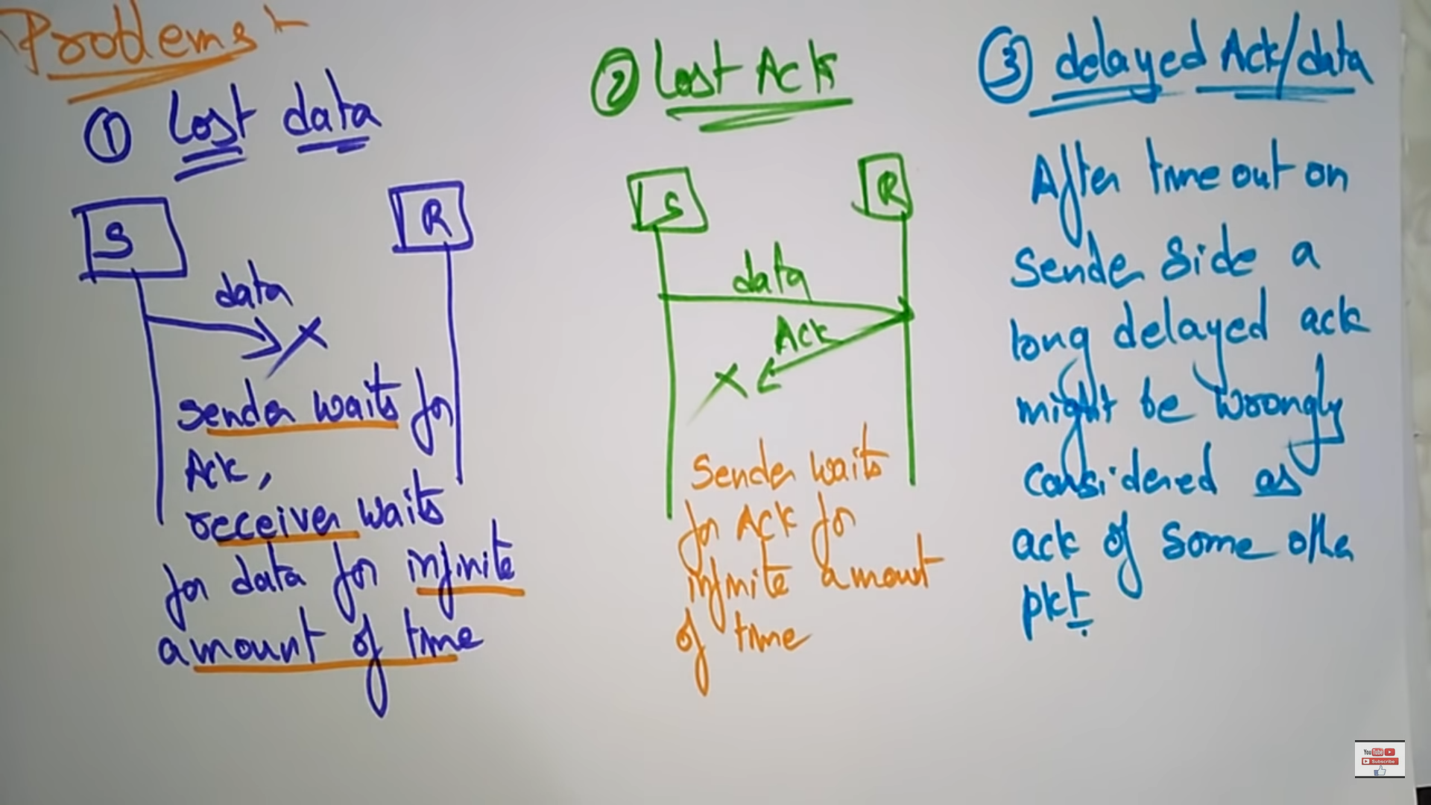

Since there is no buffer on both the sender and receiver side due to delay the sender doesn’t know / doesn’t keep track of sending the data bits.

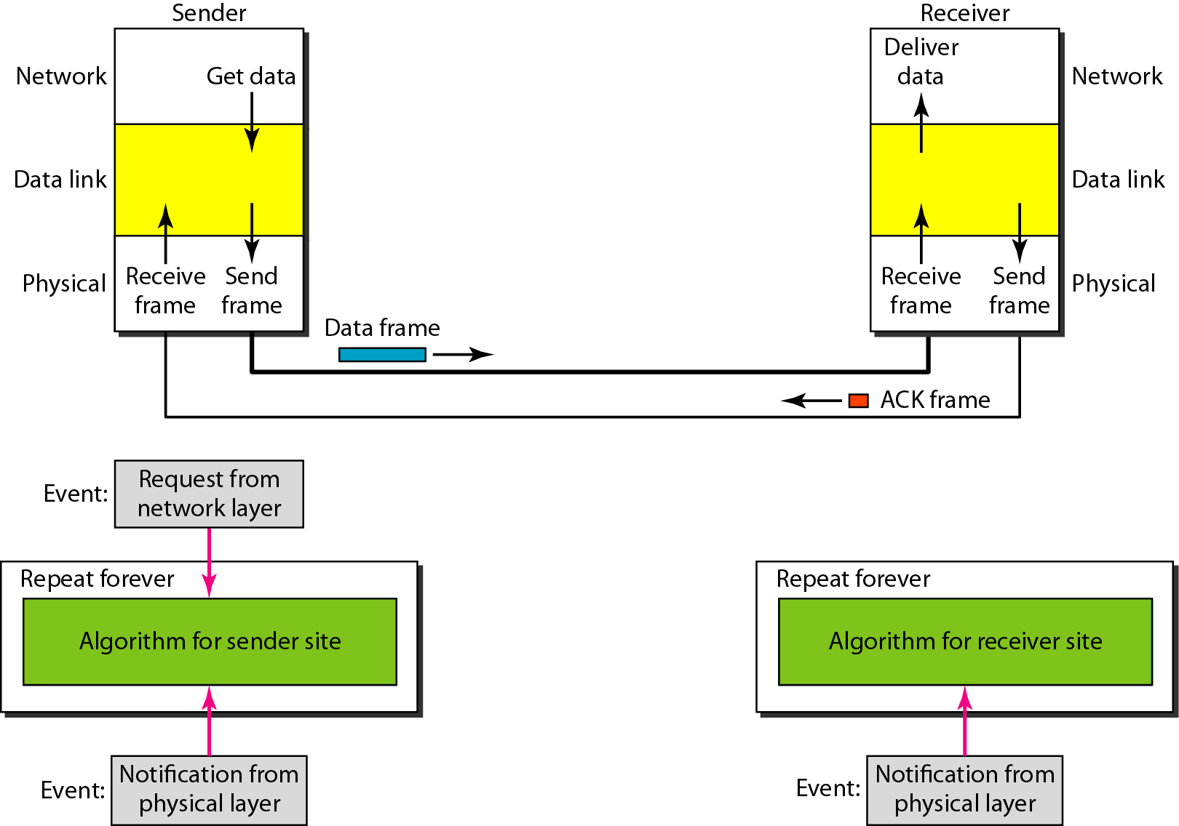

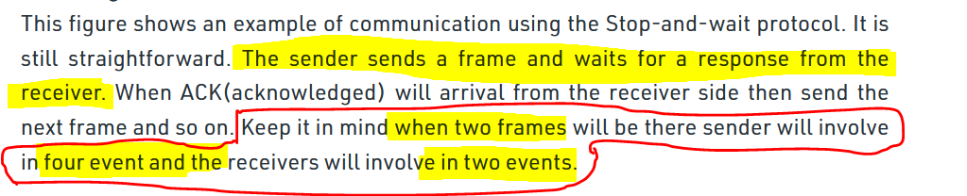

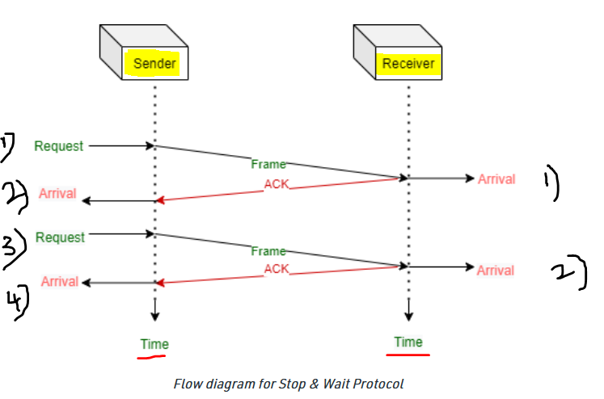

# **Noisy channel**

## **Stop and wait with ARQ**

Handles both the error and flow control.

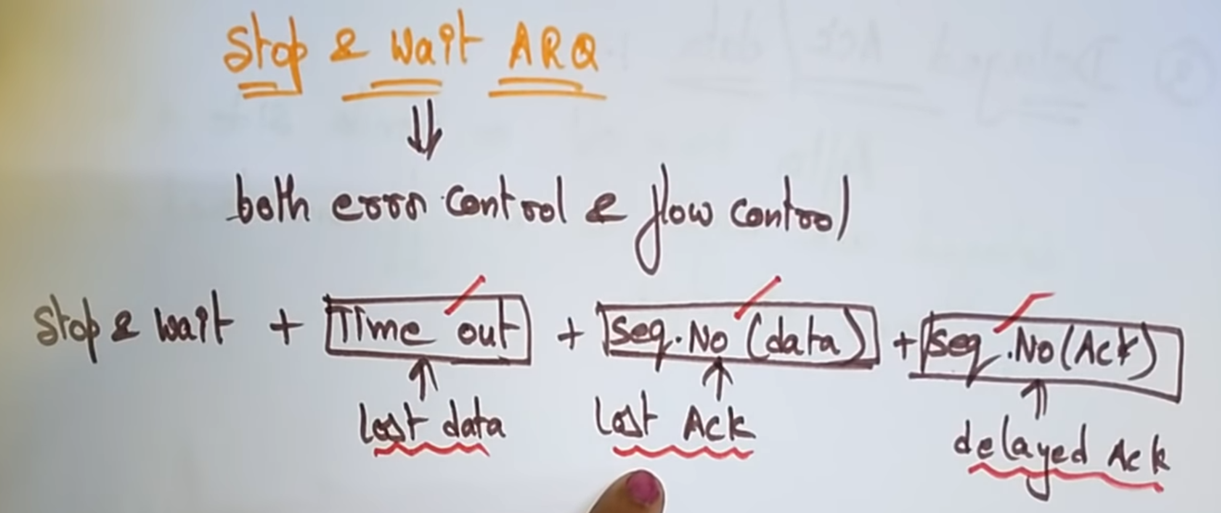

Lost data + lost data + delayed acknowledgement 🡪 3 problems in simple Stop and wait.

With **Time out** we can overcome the **problem of Lost data**.  
With **Sequence No(data)** we can overcome the **Lost acknowledgement.**  
With **Sequence No(acknowledgement)** we can overcome the **delayed acknowledgement.**

### **Time out**

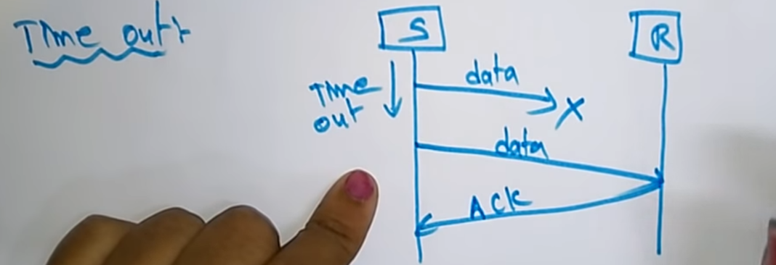

The sender will keep a clock(i.e 2s), within that 2s if the acknowledgement is not received by, the sender will send the same data once again.   
With this the problem of losing the data is prevented.

### **Sequence Number (for data)**

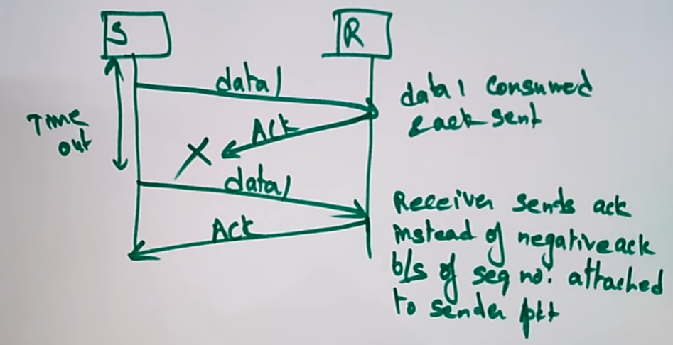

Here the data is only having the sequence number.  
Acknowledgement is not having the sequence number.  
This is resolved by introducing the sequence number for sender data.  
Here the acknowledgement of data-1 is not received by the sender.   
So data 1 is sent once again, and on receiving the acknowledgement for data-1, the sender sends data2. With this the problem of lost acknowledgement is prevented.

### **Sequence Number (for acknowledgement)**

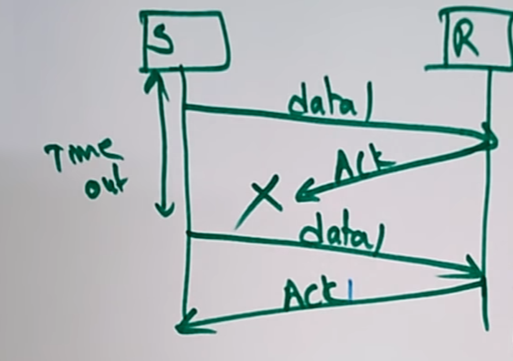



Here the data is having the sequence number.  
Acknowledgement is also having the sequence number.

If the acknowledgement is lost or data is lost, the sender will resend the data once-again.

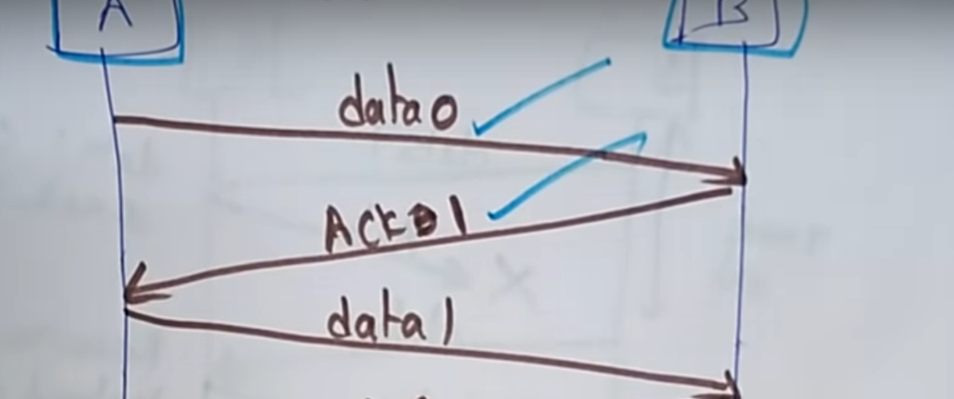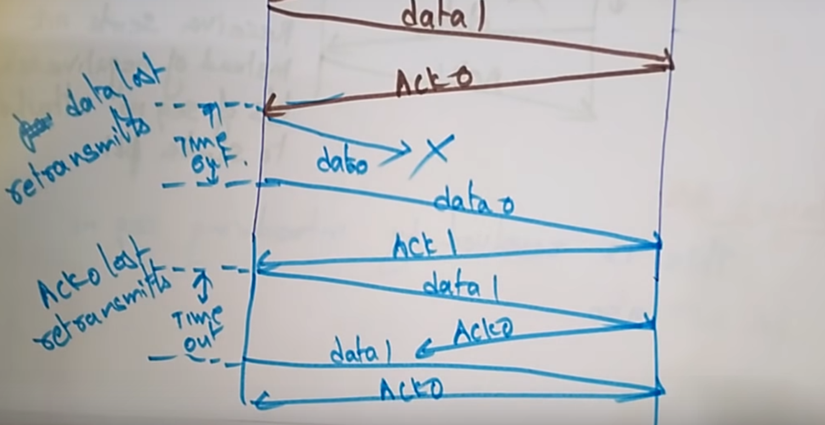



If the acknowledgement/data is lost, the sender will send the data once again.

**Advantages:**  
* Noisy channel.  
* Flow and error control mechanism.  
* Timer implementation.

**Disadvantages:**\* Efficiency is very less.* Sender can send only 1 frame at a time.   
* Multiple frames cannot be sent at an instant. **\*** No process of sending the packets together at a same time.

To increase the efficiency, Sliding window Protocol comes into the picture.

## **Sliding Window protocol**

Primarily an error control protocol.   
It is used to increase the efficiency of stop and wait ARQ.  
It handles both the error control and flow control.

Sender will move right when-ever the acknowledgment is received.  
Receiver will move right when the acknowledgement is sent.

## **Go Back N ARQ**

Stop and wait 🡪 can send only one frame at a time. After acknowledgement only the sender can send the next frame.  
Sliding Window protocol 🡪 can send multiple frames at a time. Before an acknowledgement the sender can multiple frames.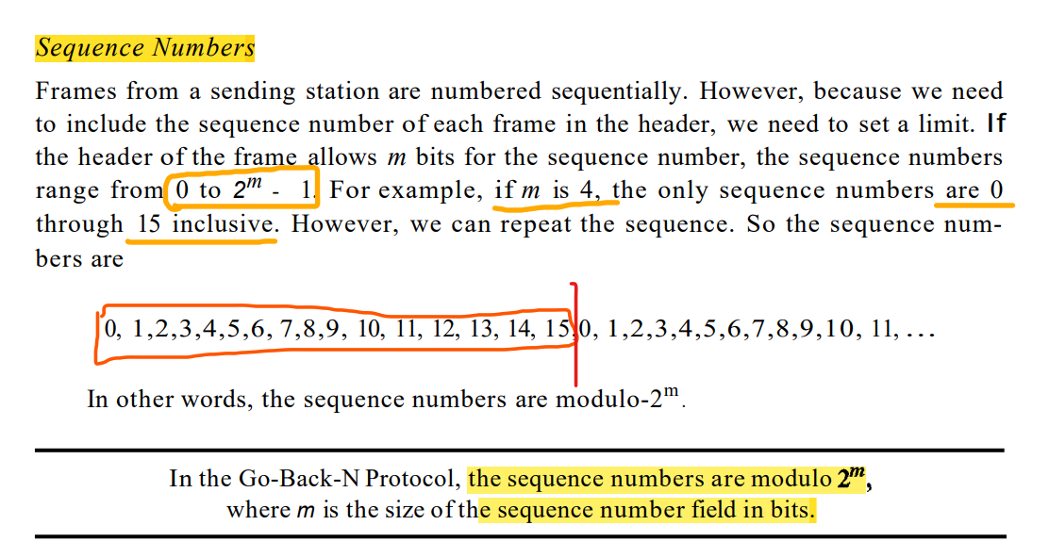

*Sender Window*

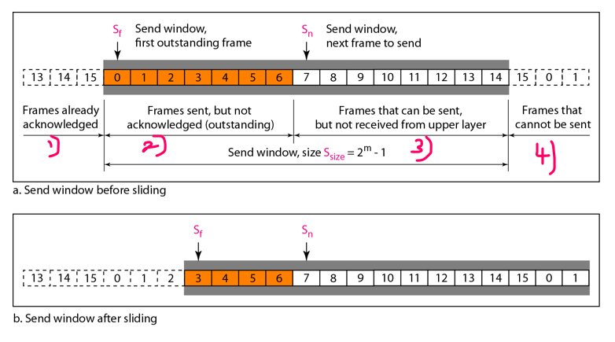

1st region 🡪 from the far left to the left wall of the window, defines the sequence from the far left to the left wall of the window, defines the sequence.

2nd region 🡪 defines the range of sequence numbers belonging to the frames that are sent and have an unknown status. The sender needs to wait to find out if these frames have been received or were lost. ***We call these outstanding frames.***

3rd region 🡪 defines the range of sequence numbers for frames that can be sent; however, the corresponding data packets have not yet been received from the network layer.

4th region 🡪 defines sequence numbers that cannot be used until the window slides, as we see next.

Sf (send window, first outstanding frame) 🡪 defines the sequence number of the first (oldest) outstanding frame.  
Sn (next window, the next frame to be sent) 🡪 holds the sequence number that will be assigned to the next frame to be sent.  
S size 🡪 defines the size of the window, which is fixed in our protocol.

*Receiver Window*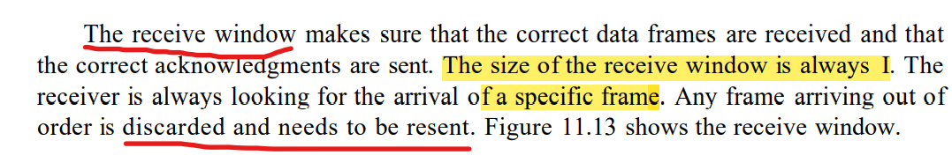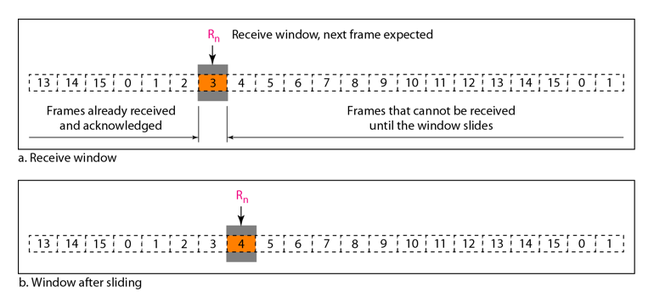

1st region 🡪 the sequence numbers to the left of this window belong to the frames already received and acknowledged.

2nd region 🡪the sequence numbers to the right of this window define the frames that cannot be received.

Any received frame with a sequence number in these two regions is discarded. Only a frame with a sequence number matching the value of Rn is accepted and acknowledged. The receive window also slides, but only one slot at a time. When a correct frame is received (and a frame is received only one at a time), the window slides.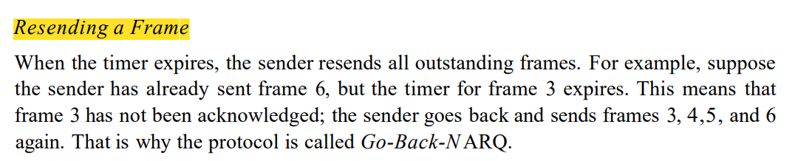

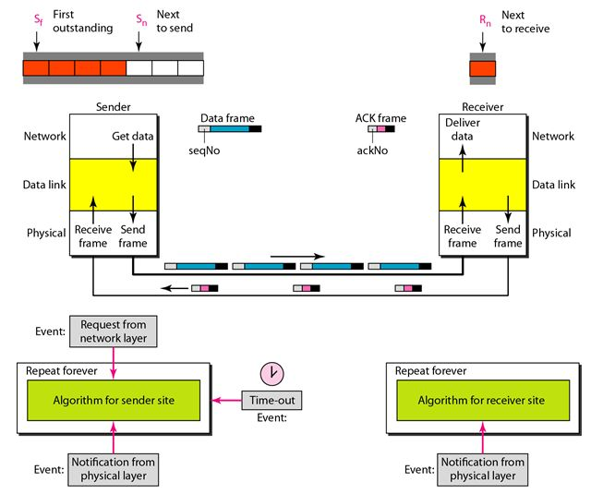

Why the size of the window should be less than 2^m ???

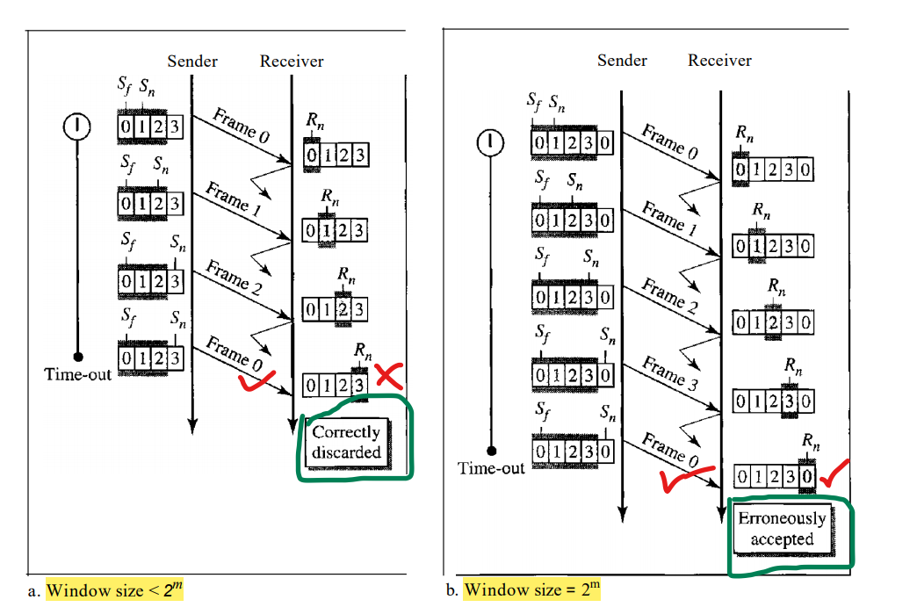

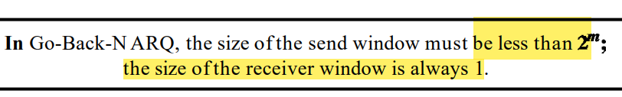

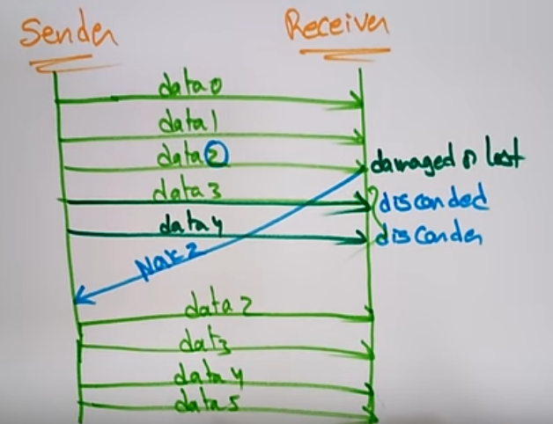

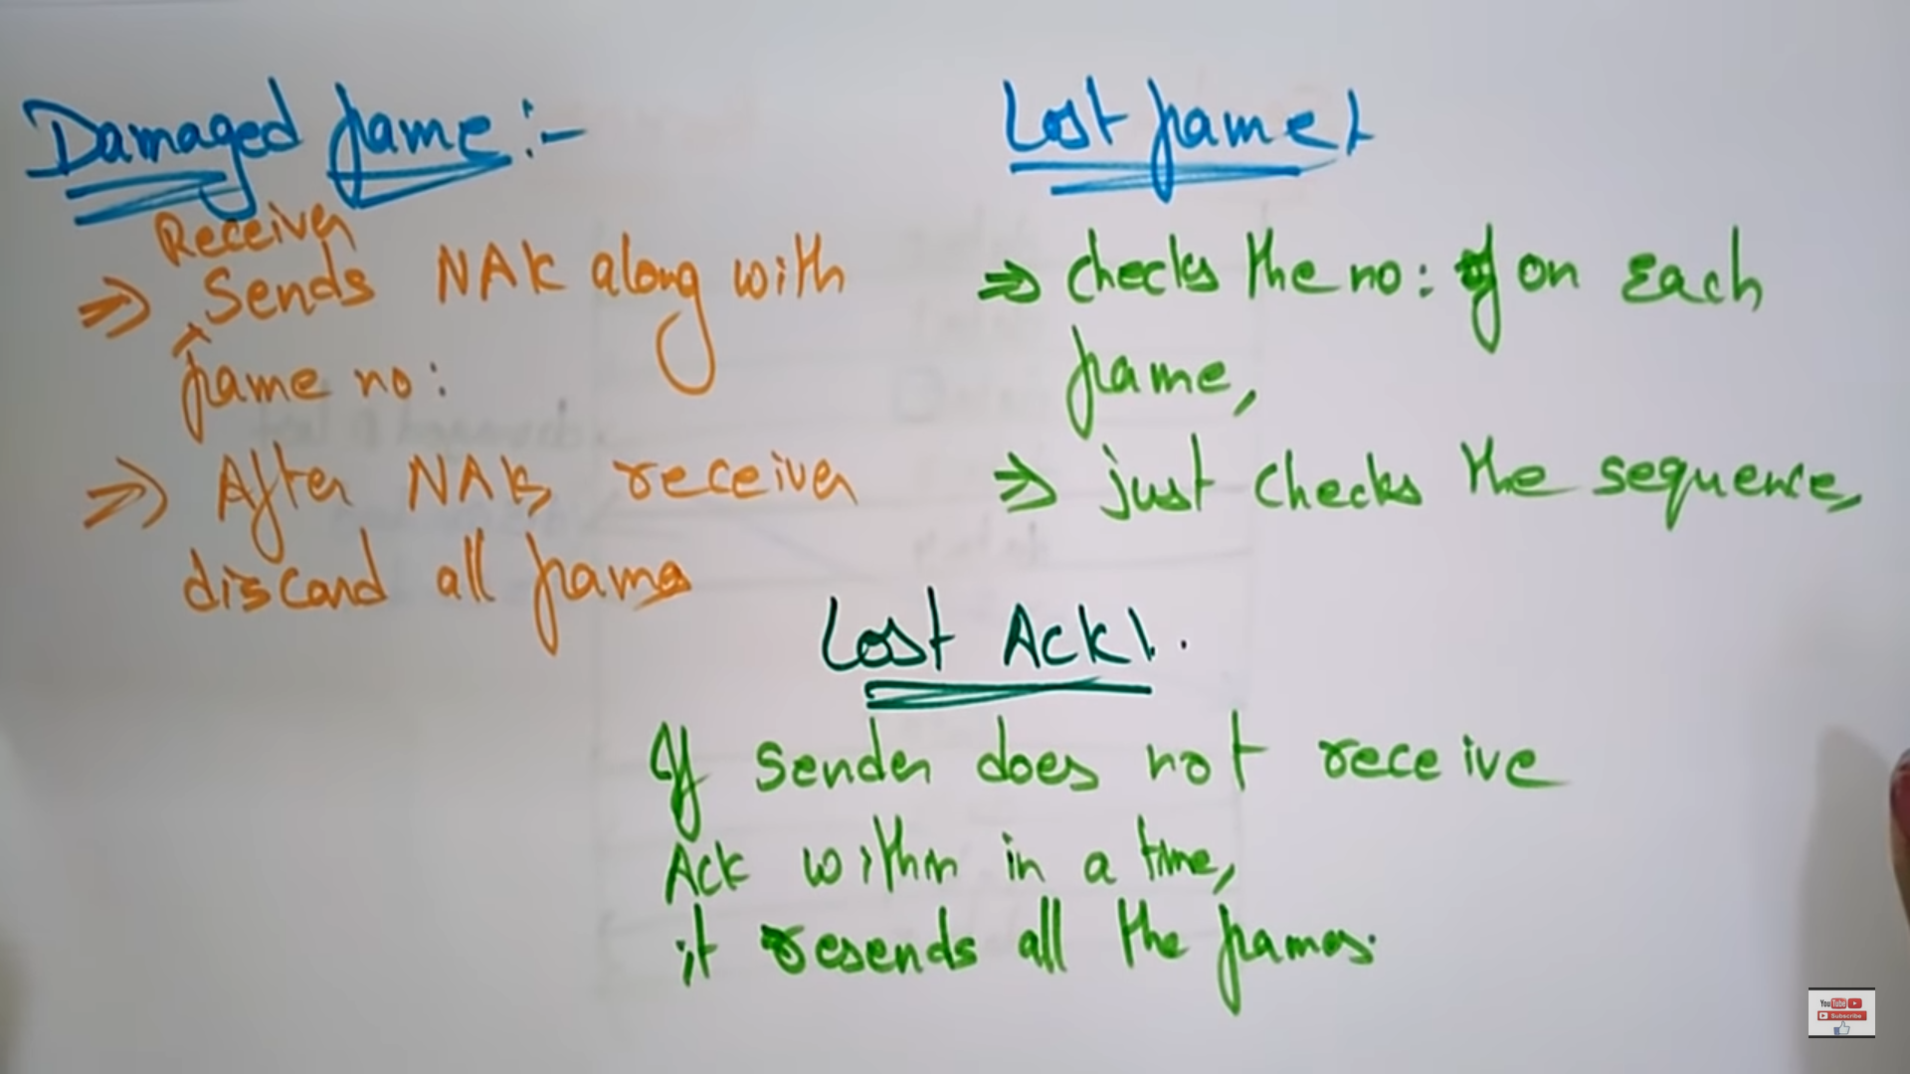

### **Scenario-1**

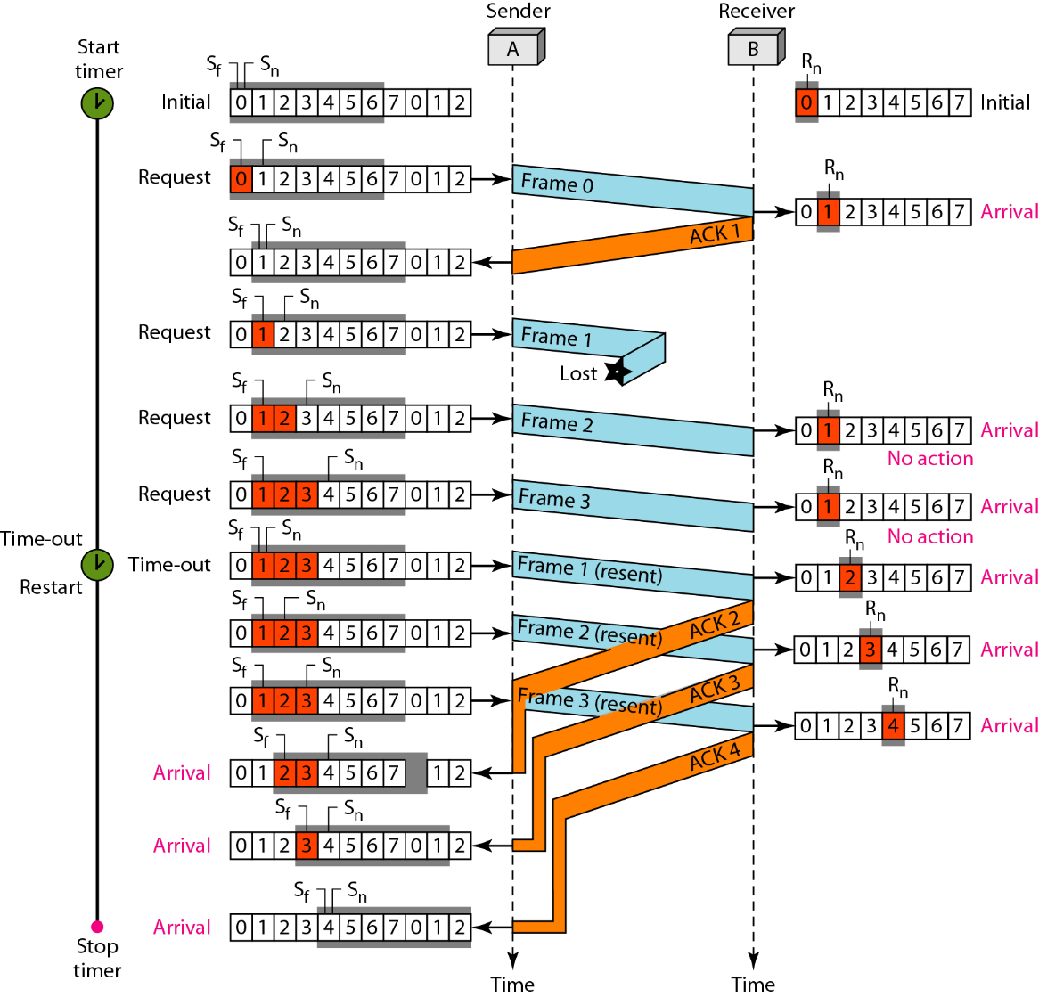

Figure 7 shows what happens when a frame is lost. Frames 0, 1, 2, and 3 are sent. However, frame 1 is lost. The receiver receives frames 2 and 3, but they are discarded because they are received out of order. The sender receives no acknowledgment about frames 1, 2, or 3. Its timer finally expires. The sender sends all outstanding frames (1, 2, and 3) because it does not know what is wrong. Note that the resending of frames 1, 2, and 3 is the response to one single event. When the sender is responding to this event, it cannot accept the triggering of other events. This means that when ACK 2 arrives, the sender is still busy with sending frame 3.

The figure shows that because of one packet lost, all following  
packets will need to be retransmitted, even if they have arrived at the destination 🡪 A great waste of bandwidth.

### **Scenario-2**

## **Selective Repeat Request ARQ**

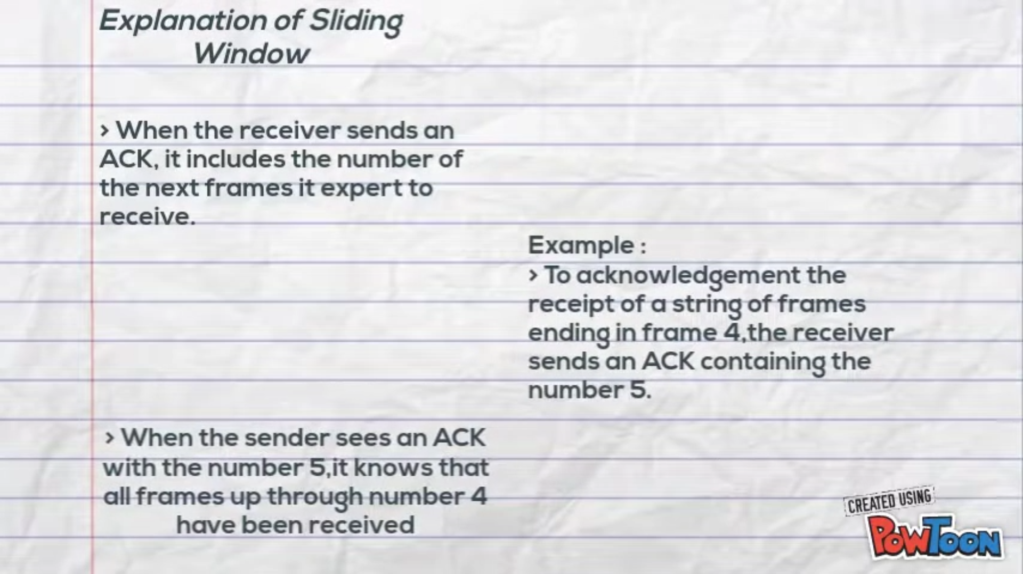

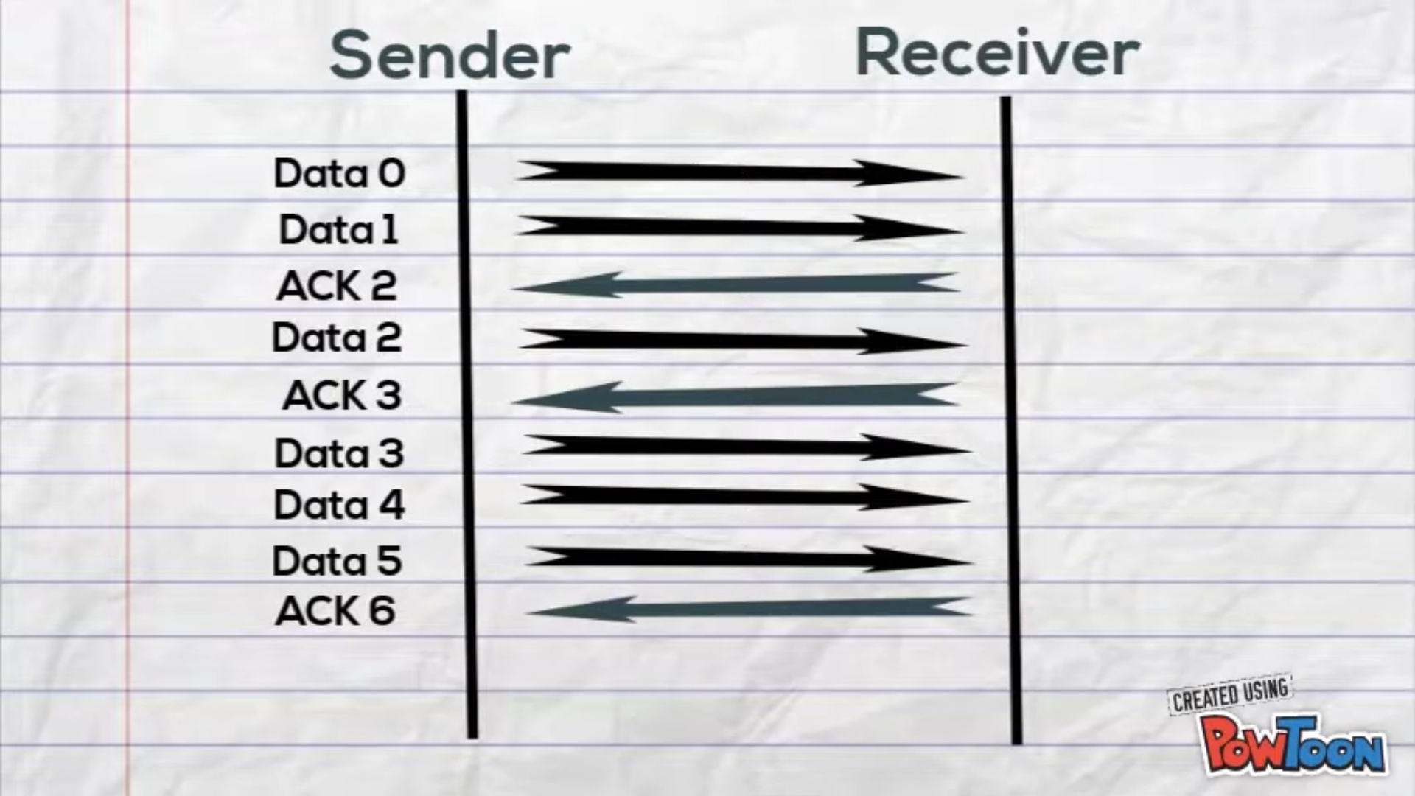

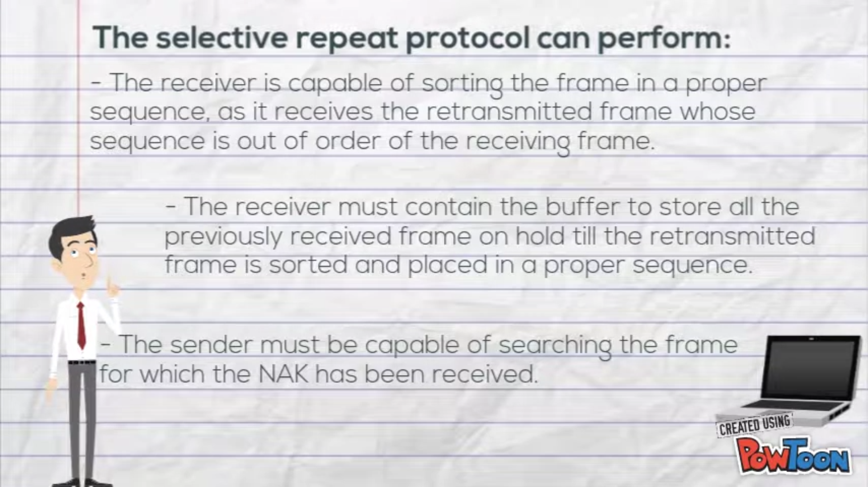

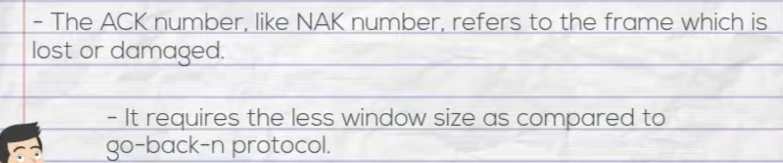

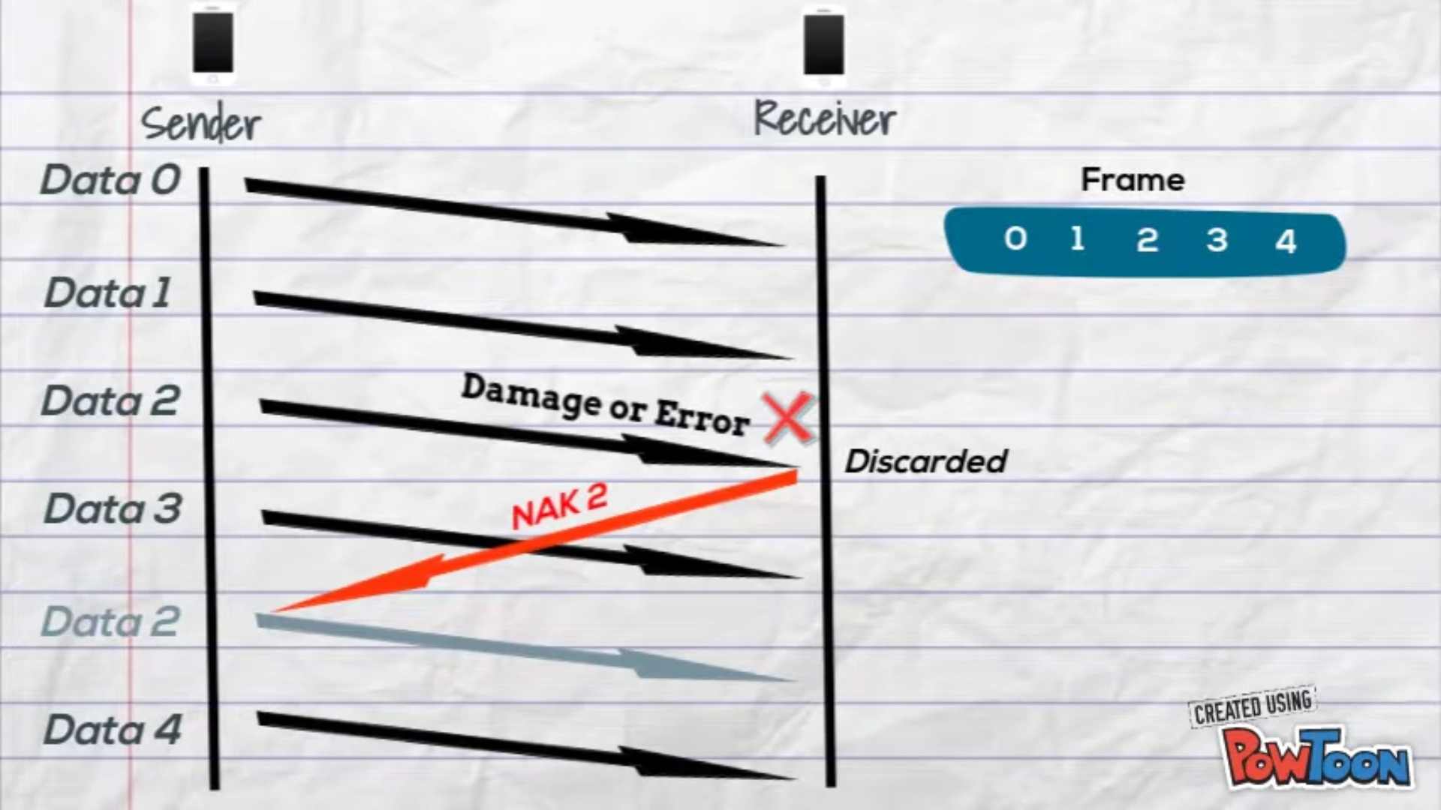

# Finite State Machine (FSM)



**Wait for call0 from above:**  
rdt_send(data)  
sndpkt = makepkt(0,data,checksum) 🡪 Sending data0  
udt_send(sndpkt)  
**start_timer**

**Wait for ACK1: (self-loop)**udt_rcv(rcvpkt) && ( corrupt(rcvpkt) || isACK(rcvpkt,0) ) 🡪 receiving data0

timeout 🡪 If the sender doesn’t receive the acknowledgment, it will resend the data and



udt_send(sndpkt) start the timer  
**start_timer**

**Wait for ACK1: (from 1 state to another)**udt_rcv(rcvpkt) && notcorrupt(rcvpkt) && isACK(rcvpkt,1)   
**stop_timer**



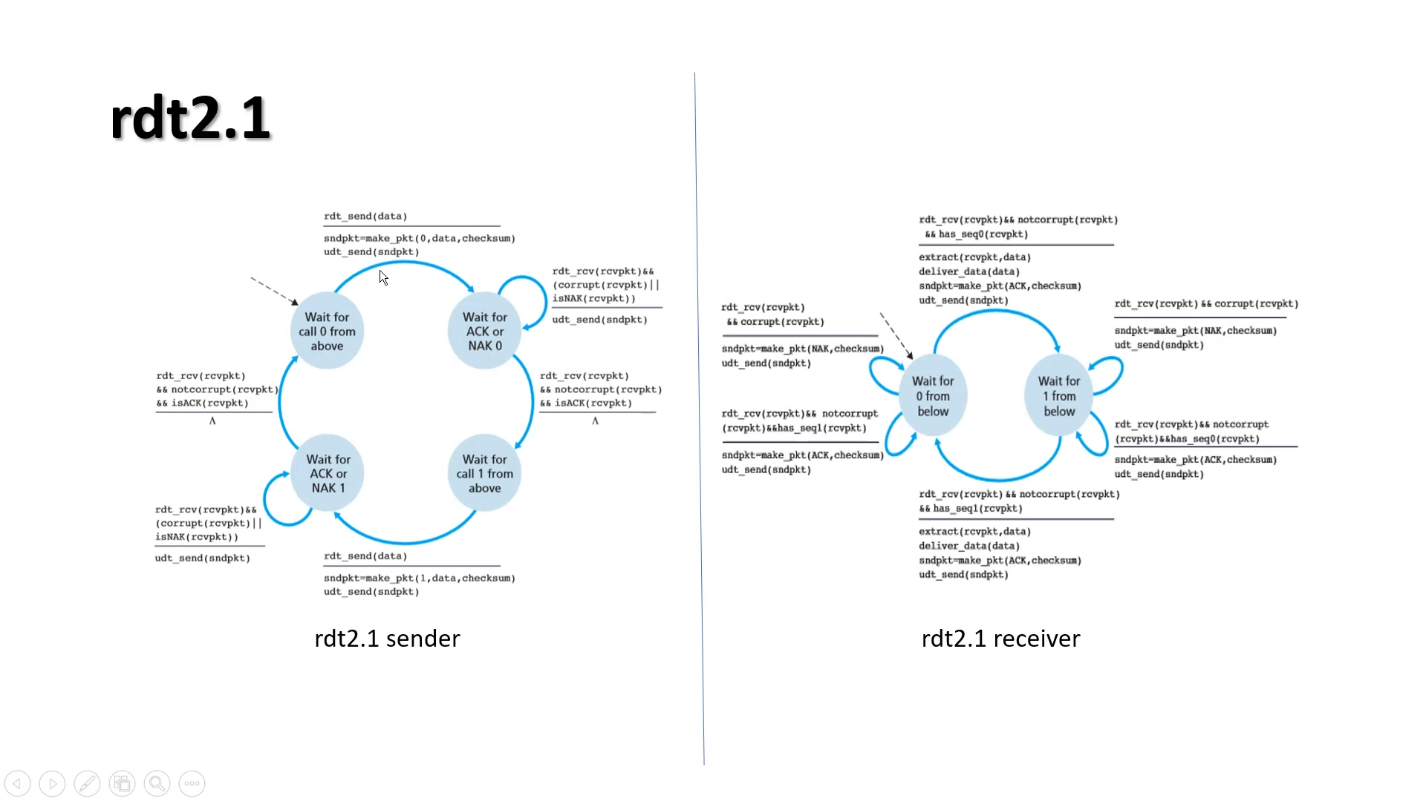

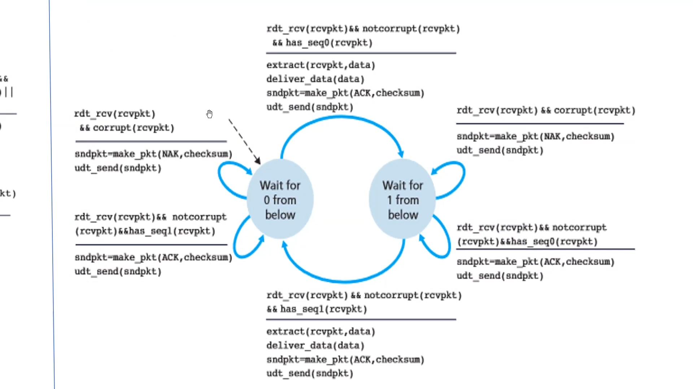

Wait for 0 from below   
Will except the data with sequence number 0

Will accept sequence1 also send ACK, but will not extract the data from the packets received.

Wait for 1 from below   
Will except the data with sequence number 1

# Implementation

## Sender

1)Data must be sent from the network layer to physical layer  
Data will be coming in the form of packets, these packets must be converted into frames and then sent to the physical layer

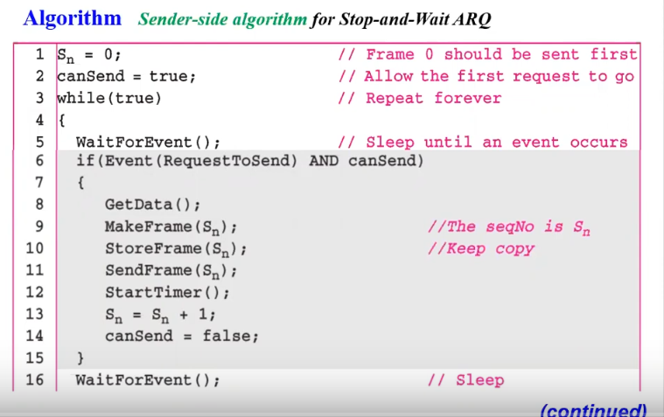

After getting the data from network layer, we will create a frame with sequence number and store the frame, in-case if the frame is lost we have to resend the frame once again.  
Send the frame and the start the timer, we will increase the sequence number.  
flag canSend=False (until we receive the acknowledgment next frame can’t be sent)

### 2) When the acknowledgement have arrived

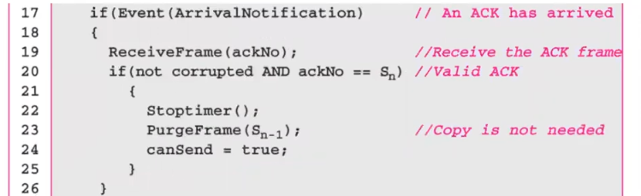

First we Should check if the frame is not corrupted and the acknowledgment number is equal to the next frame which we want to send.  
We will stop the timer, purge the frame which was sent and make the flag true, indicating the completion of the event.

### 3) When the timer was expired

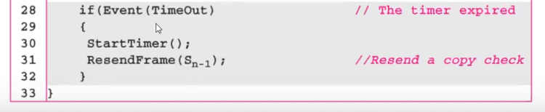

## Receiver

